PIMPRI CHINCHWAD EDUCATION TRUST'S

PIMPRI CHINCHWAD COLLEGE OF ENGINEERING

Department of AS&H
Report of FA-2 activity

Subject: BSH23OE04: Open Elective: Statistical Data Analysis using R
Academic Year 2026-27
Semester I
Submitted by Name of the student: PRN number Branch
1.
2.
3.

Submitted to: Dr. Rajesh G Talekar
Date:
Sign:

Project Title: Descriptive analysis of HR Employee data of MNC Company
Data used: HR data from a MNC company
Details of the data: Data contains 14999 observation and 11 variables as follows
1. Emp_ID- Id of Employee
2. satisfaction_level- Satisfaction level of employee in percentage. 100% or 1 is very satisfied. 0% or 0 is not satisfied
3. last_evaluation- Time from last evaluation in year
4. number_project-Number of projects an employee is working on
5. average_montly_hours-Average hours worked by employee in last 3 months
6. time_spend_company-Time spend my employee commuting to office
7. Work_accident-If the employee was involved in a work accident
8. lefts- If the employee has left the company
9. promotion_last_5years- If the employee has a promotion in past 5 years
10. Department- Department employee is working in
11 salary

Flow:
Problem Statement
Statistical Analysis
Data Visualization
Coding
Correlation if possible.
Hypothesis testing with proper sampling

Problem statement 1: Whether unsatisfied employee leaving the company
The data is grouped by employee who left the company, and average level of satisfaction and variations in values of level of satisfaction is calculated, results are as follows,
Left | Averge level of satisfaction | Variations in level of satisfaction
0 | 0.66680959 | 0.217103755
1 | 0.440098012 | 0.263933436
It shows that, average of level of satisfaction is less for employee who left the company, so it may be one of the reason for leaving the company. It can be visualise by boxplot as follows

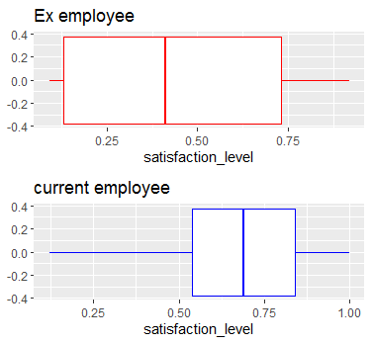
It clearly shows greater variations in level of satisfaction of employee who left the company that is employee hold quite different opinions about level of satisfaction opposite to that a high level of agreement is observed in level of significance of employee who still working in the company.

Problem statement 2:
Problem statement 3:
Problem statement 4:
Problem statement 5:
Overall Conclusion:
1.
2.
3.
4.
5.

